# Sales Performance Dashboard Report

## Overview

This Sales Performance Dashboard is designed to provide a comprehensive and interactive overview of sales data. It allows users to explore historical sales trends, analyse key performance indicators, detect outliers, and forecast future sales using time-series modelling. The dashboard is built using **Streamlit** for a user-friendly web interface, **Pandas** for data processing, **Plotly** for interactive visualizations, and **Prophet** for forecasting.

## Data and Filters

* The dashboard loads cleaned sales data from a CSV file containing sales transactions with details such as date, sales amount, product, category, price, and stock.
* The dataset is enriched by extracting **time features** such as year, month, day of the week, and day names to enable time-based filtering and analysis.
* The sidebar provides filtering options:
  + **Year**: Users can select a specific year to analyse.
  + **Months**: Users can select one or multiple months within the selected year.
* Filtering allows users to focus on relevant subsets of data and update the dashboard dynamically.

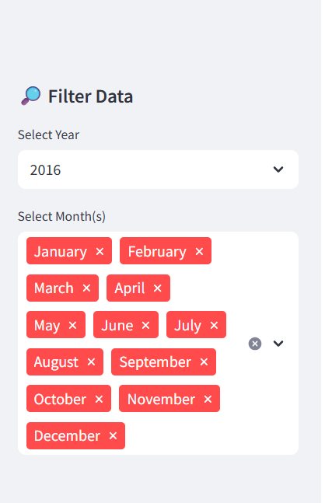

### 1. Key Performance Indicators (KPIs)

* **Total Sales:** Displays the sum of sales within the selected timeframe, providing an overview of overall revenue.
* **Average Price:** Shows the mean selling price of products, useful for tracking pricing trends.
* **Average Stock:** Indicates the average stock levels during the period, helping monitor inventory status.

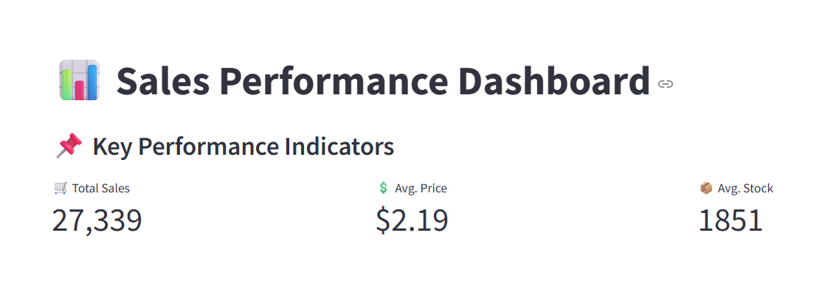

### 2. Sales Over Time (Line Chart)

This chart presents daily sales trends for the selected period, allowing identification of growth patterns, dips, or anomalies over time.

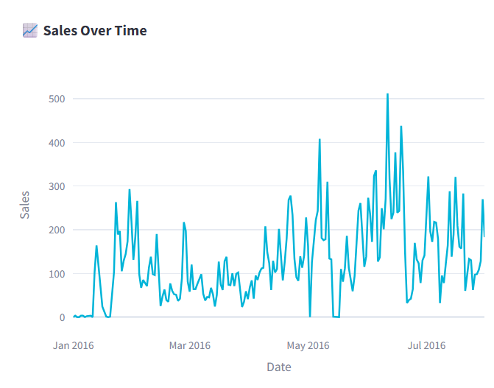

### 3. Average Sales by Month (Bar Chart)

A monthly breakdown showing average sales per month, highlighting seasonal trends and helping to plan inventory or marketing efforts accordingly.

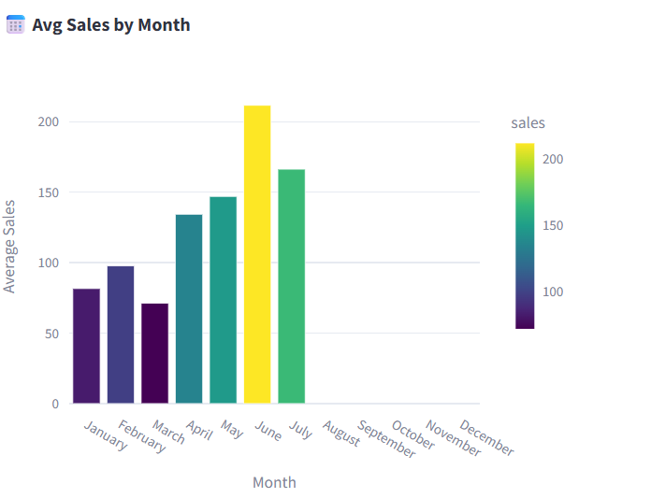

### 4. Sales Distribution (Box Plot)

A box plot visualizes the spread and variability of sales data, with all individual points shown to detect outliers or unusual sales events.

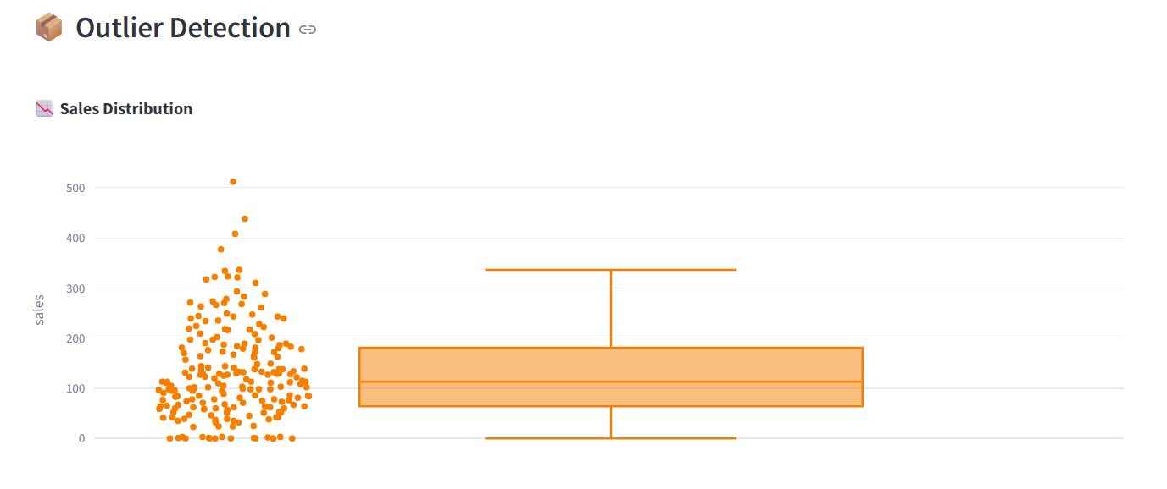

### 5. Sales Animation by Day of Week (Animated Bar Chart)

An animated visualization displays sales volume by day of the week across different months. This helps uncover weekly patterns and changes over time.

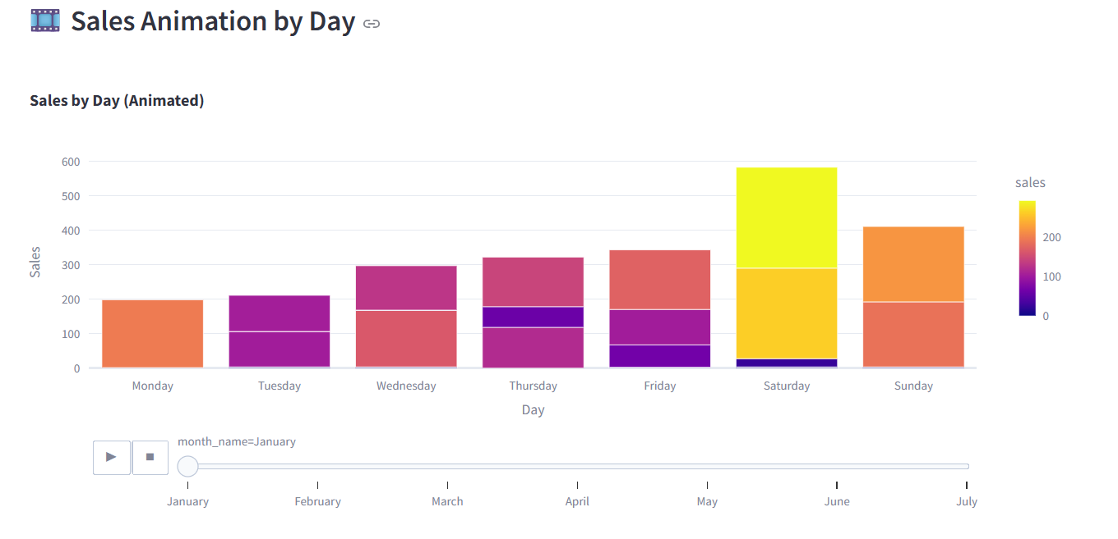

### 6. Sales Distribution: Weekday vs Weekend (Pie Chart)

A pie chart comparing total sales made on weekdays versus weekends, providing insights into consumer behaviour and peak sales days.

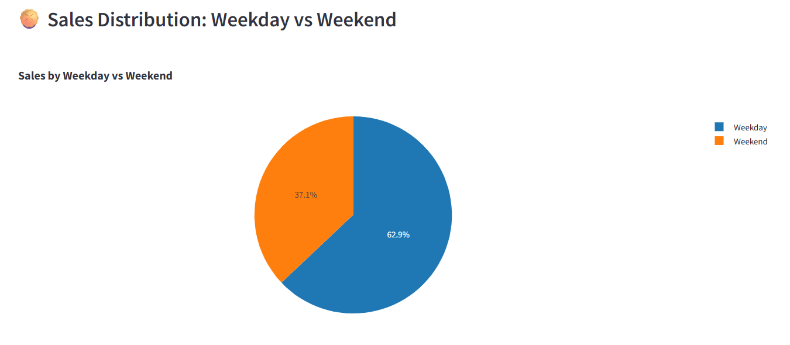

### 7. Heatmap of Sales by Day of Week and Month

This heatmap shows sales intensity categorized by day of the week and month, revealing combined temporal patterns that can inform operational decisions.

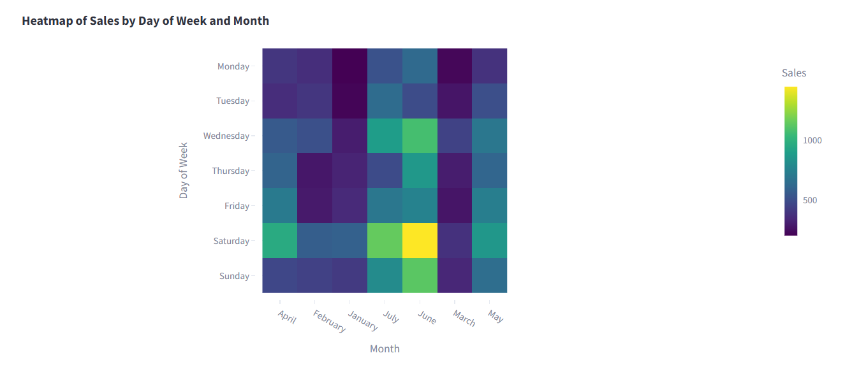

### 8. Raw Data Table and Export

The dashboard includes a data table showing the filtered sales records, along with an option to download the data in CSV format for further analysis.

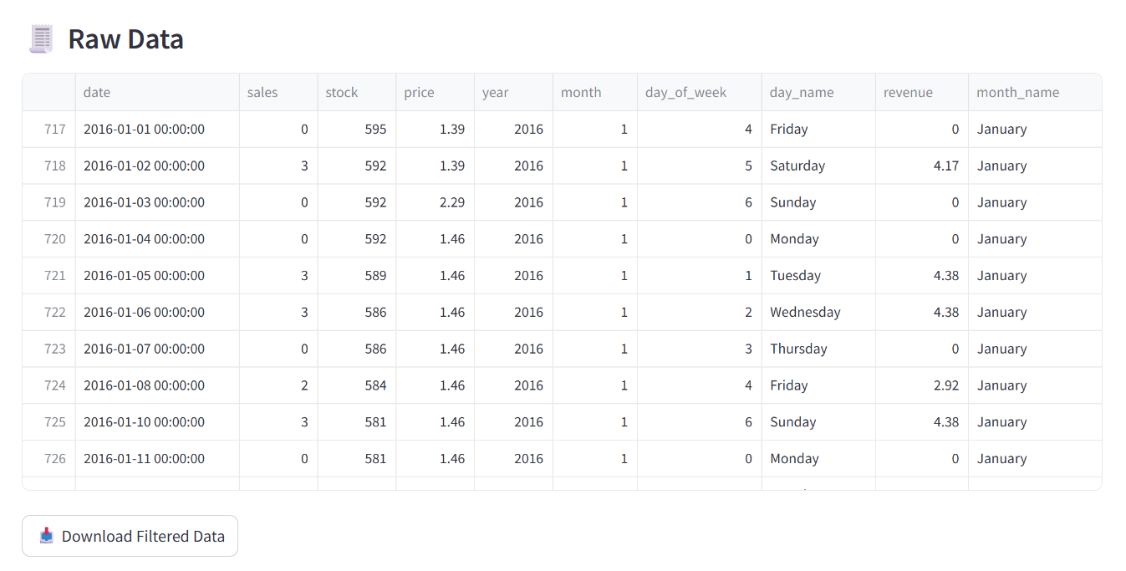

### 9. Sales Forecasting

The dashboard uses the Prophet forecasting model to predict future sales based on historical data. Users can select a forecast horizon ranging from 7 to 90 days. The forecasting output includes:

* **Predicted Sales (yhat):** This is the model’s best estimate of the expected sales for each future date. It represents the central forecast value, showing the likely sales volume based on historical trends and seasonal patterns.
* **Lower Confidence Bound (yhat_lower):** This value indicates the lower limit of the forecast at a specified confidence level (usually 80%). It represents a conservative estimate, showing the minimum sales the model expects with a high degree of confidence. If actual sales fall below this bound, it suggests an unusually low sales event.
* **Upper Confidence Bound (yhat_upper):** This is the upper limit of the forecast range at the same confidence level. It represents a more optimistic estimate of future sales. Actual sales above this bound may indicate exceptionally strong performance or an unexpected sales spike.

